UserStories BRM

Android:

1. UI
   1. Main Menu
   2. Question View
   3. Exercise Tab
   4. Exercise View
   5. Bucket
   6. Side Menu
   7. Sprint
   8. PDF Reader
   9. SynchButton (in progress)
   10. ShareView+Button (future)
2. Functionality
3. Requirements

UI

Main Menu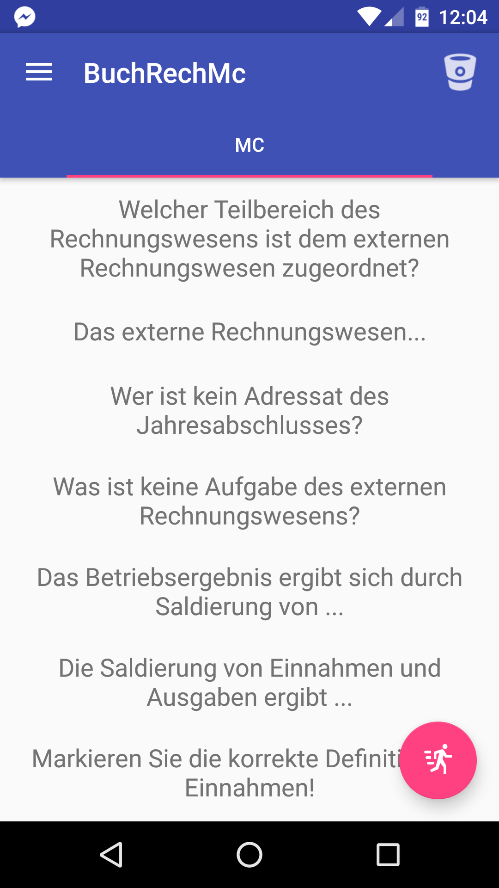

Description: On the main menu page you can see the list of all questions, floating button (right down) to access the Sprint (see Sprint), button in toolbar to access the Bucket (see Bucket), button to access the Side Menu (see Side Menu). Also here must to be two tabs “MC” with all MC questions and “Exercise” with list of all exercises (not on the Screenshot). Side menu can be awoken with button or swipe.

Question View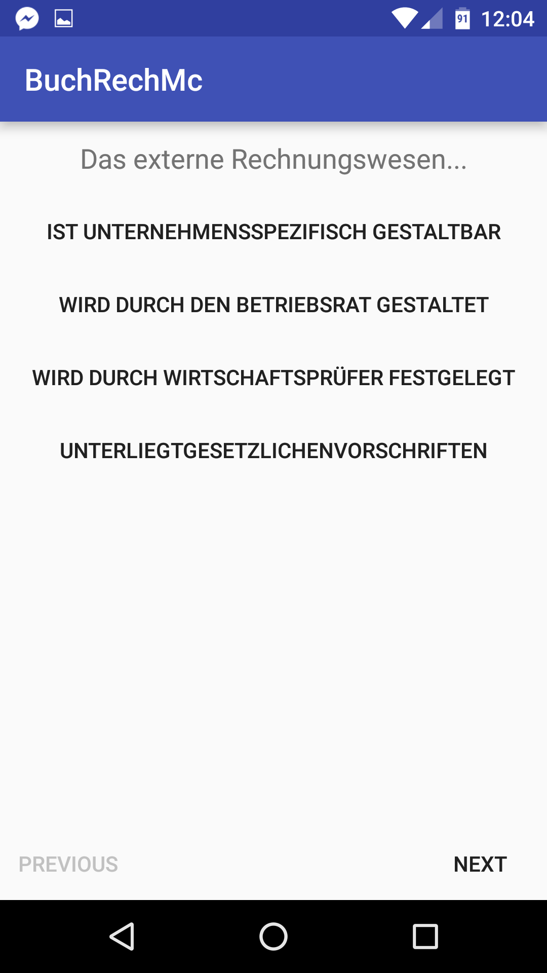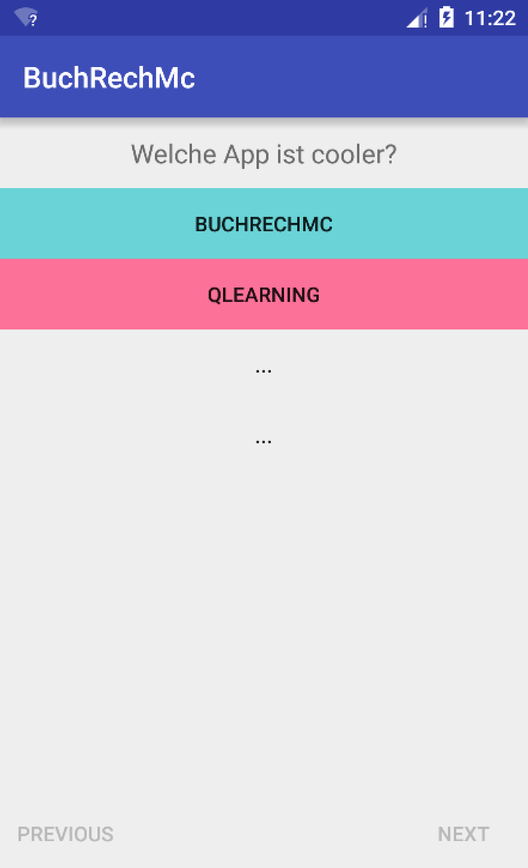

Every question has text with question above and four possible answers. Only one is right. By clicking the answer you get color. If correct answered green, if not correct then red and the right answer will be lighted up with green color. Also you have two buttons “Previous” and “Next” to navigate between questions.

Exercise Tab

This tab is only in progress. Here will be shown as list all objects exercise.

Exercise View

Coming soon

Bucket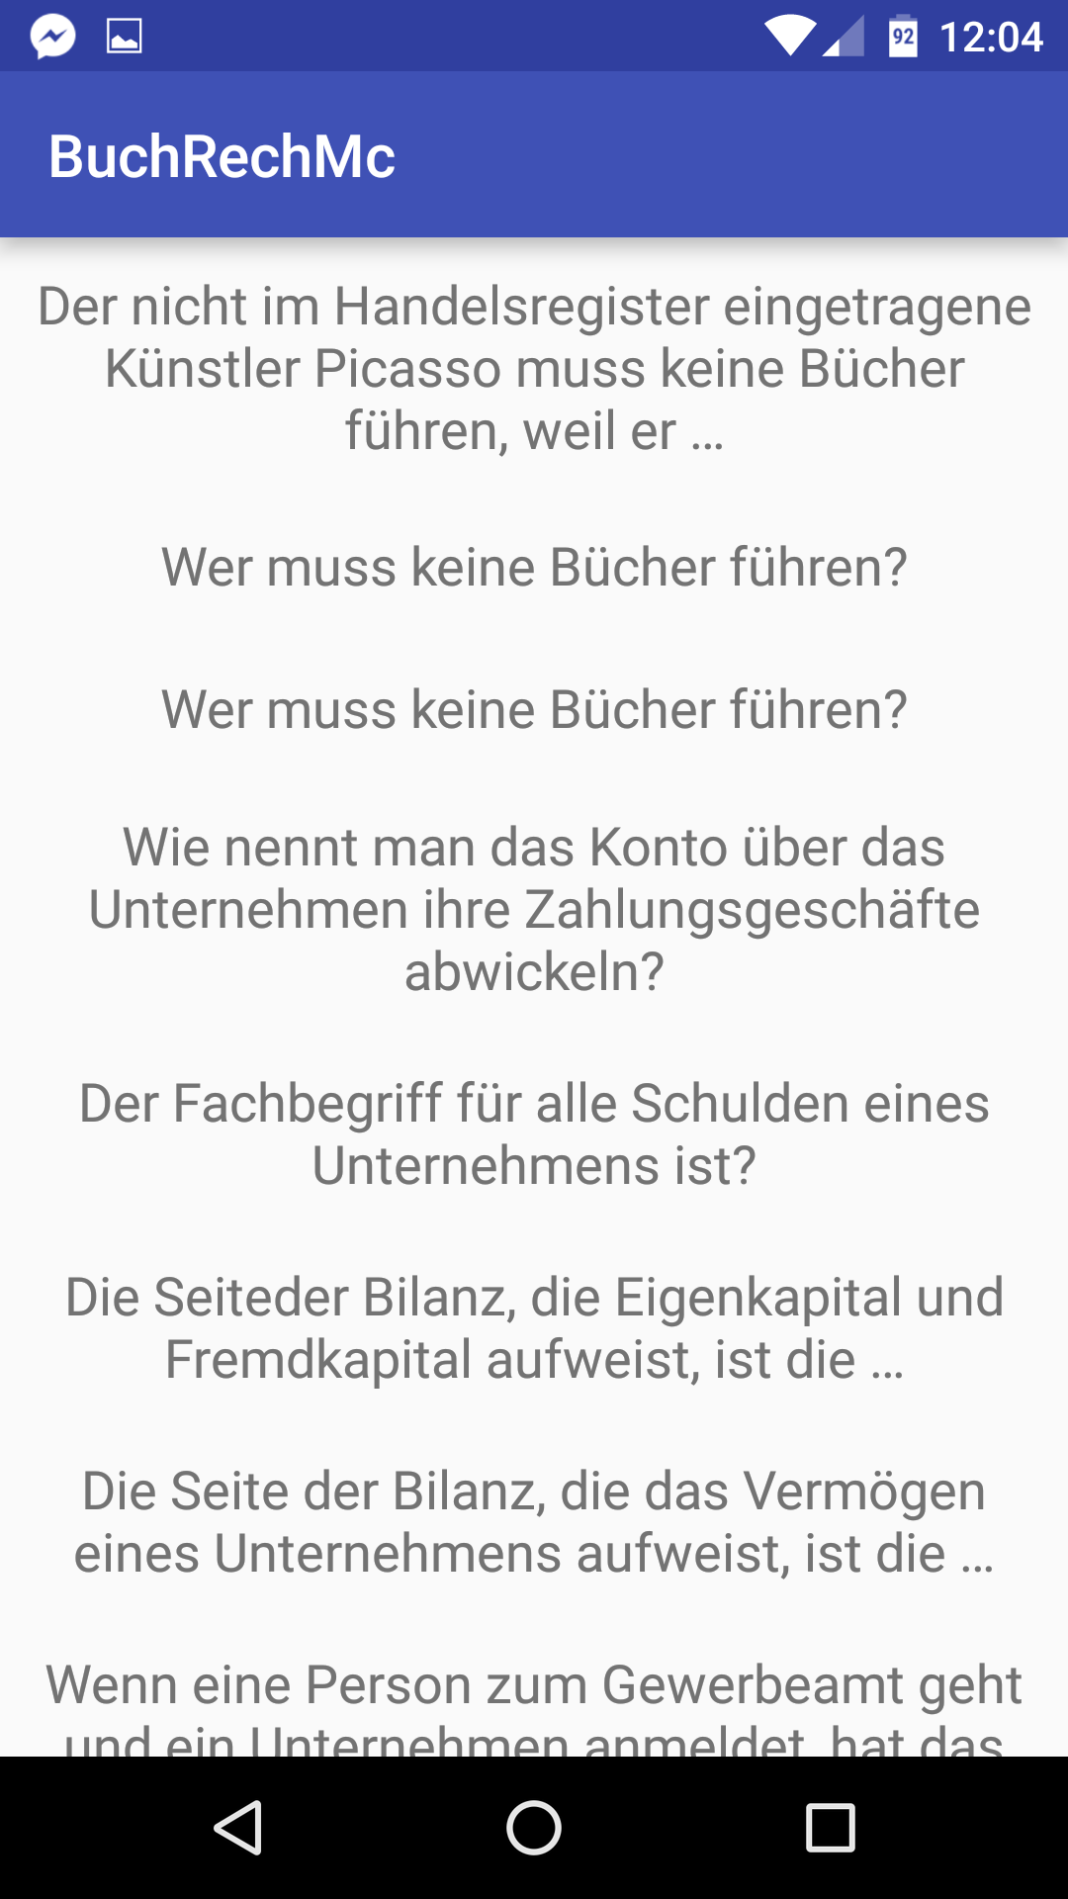

Here are all questions that was answered right 3 times in a row. It is the same list of questions like on the main page. You can also access every question and answer it. Questions that are in bucket must be stored on the end on the main page.

Side Menu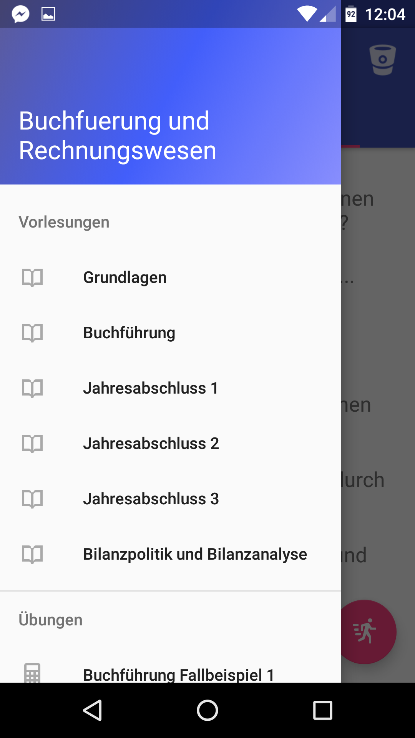

Here are listed all of PDFs from the lecture. The background image will be changed soon. Via tap you access the PDF View.

Sprint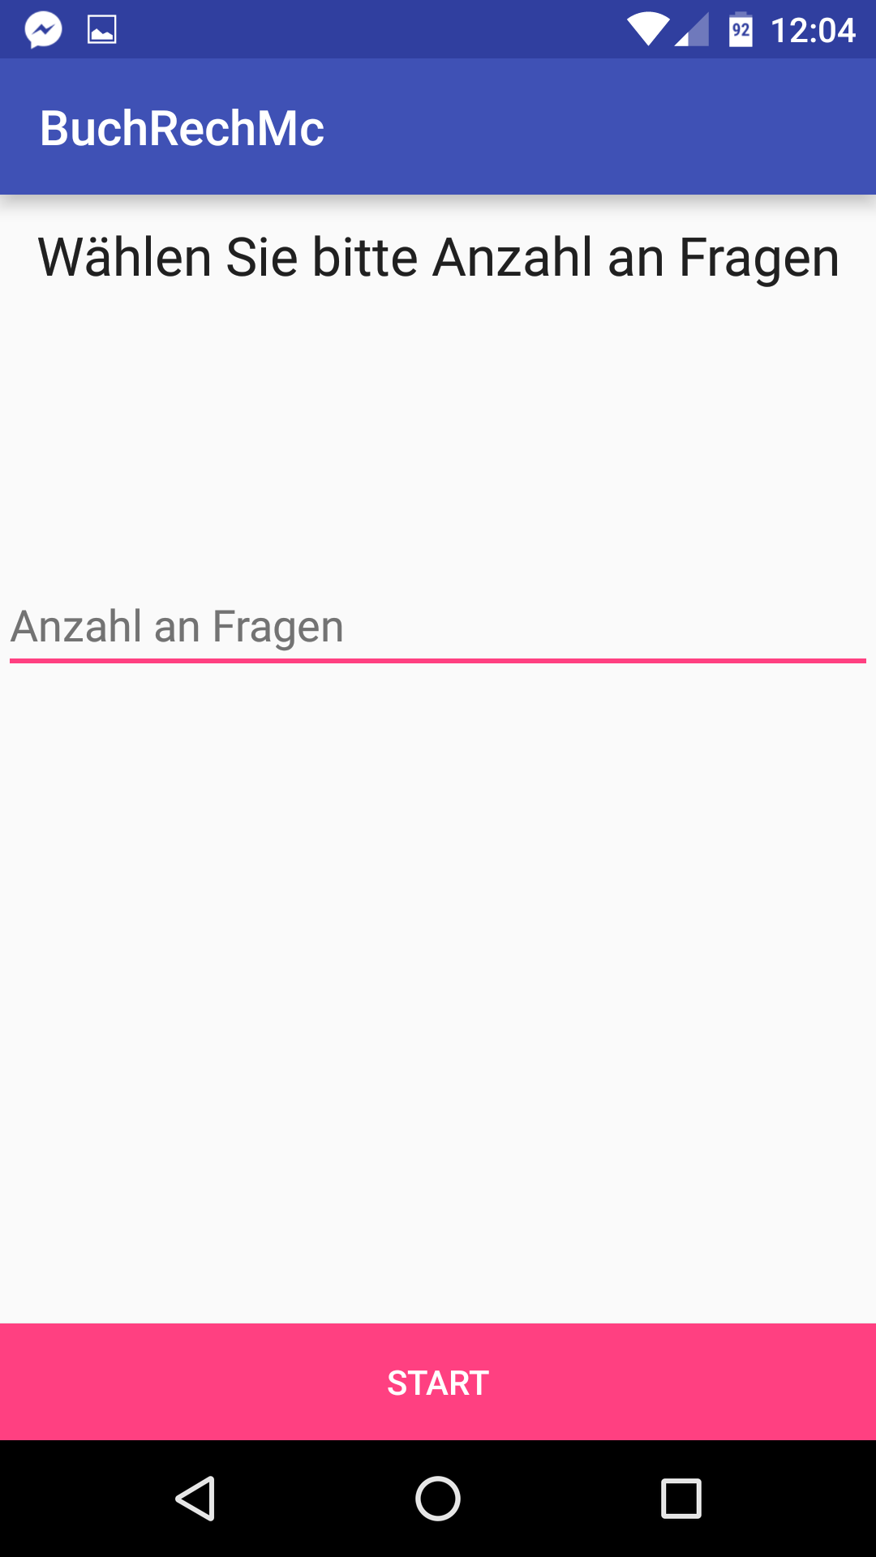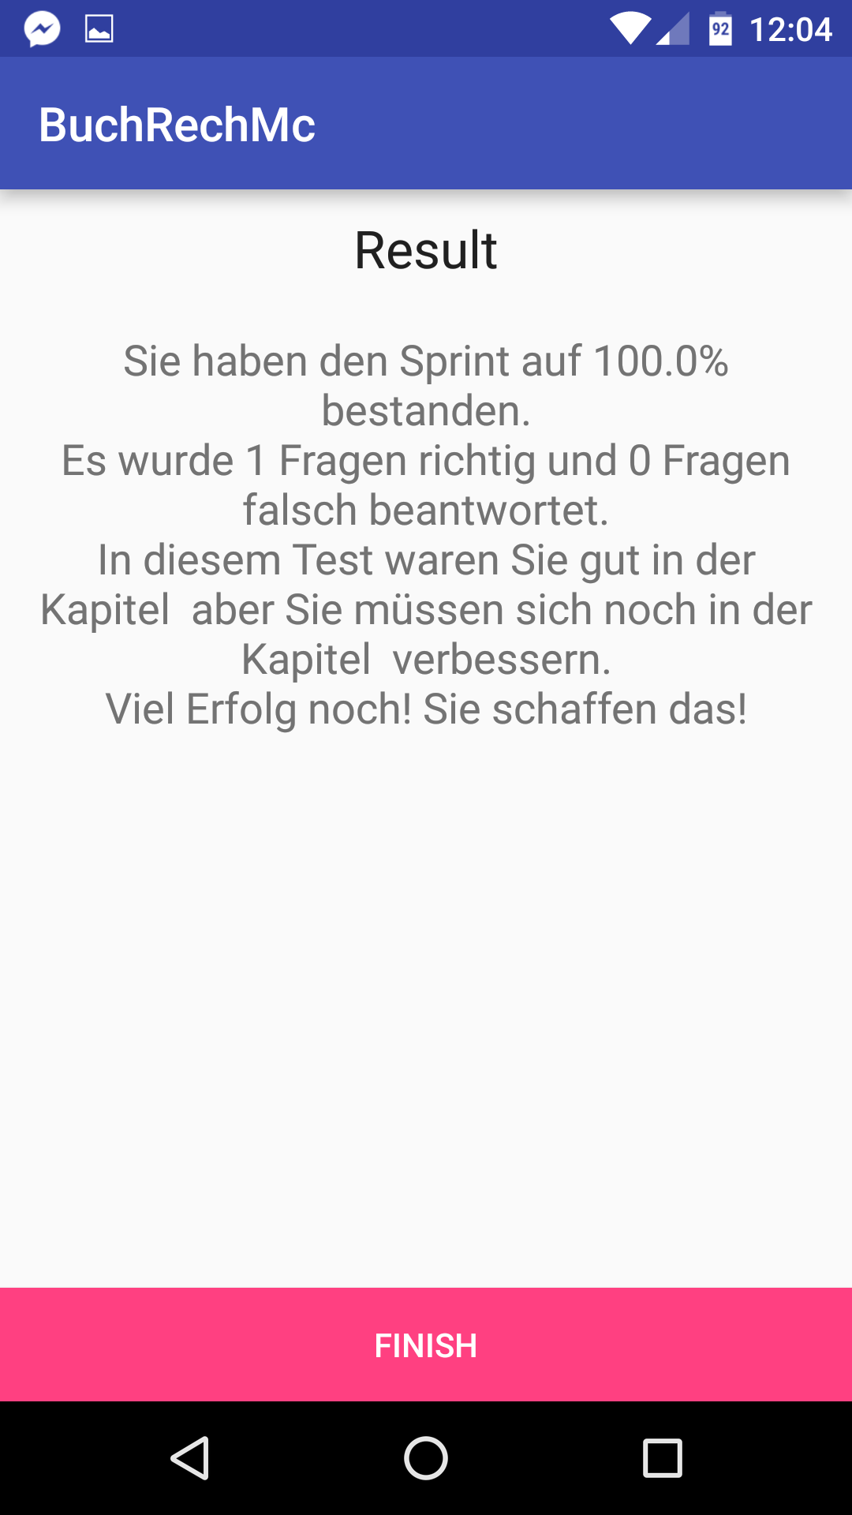

Sprint consist Start, questions and end result. On the start you can choose the amount of questions you want to test. The questions are randomly token from the whole questions list. In the future you can choose also the chapter and topics that you want to learn. Question object has as attribute “Kapitel” for that reason. At the end you get the result statistic.

PDF Reader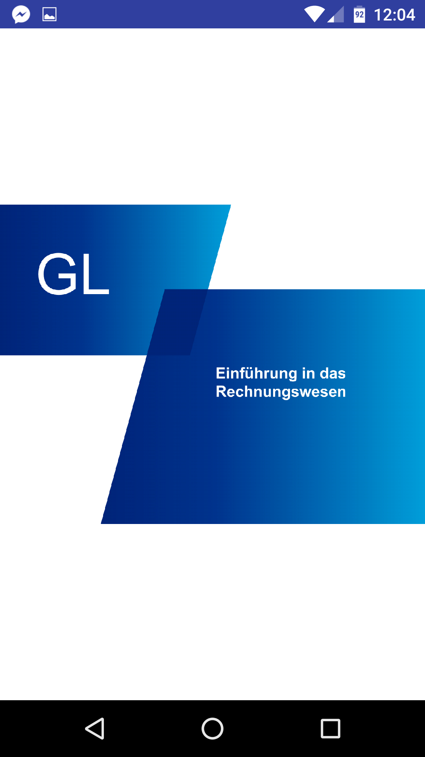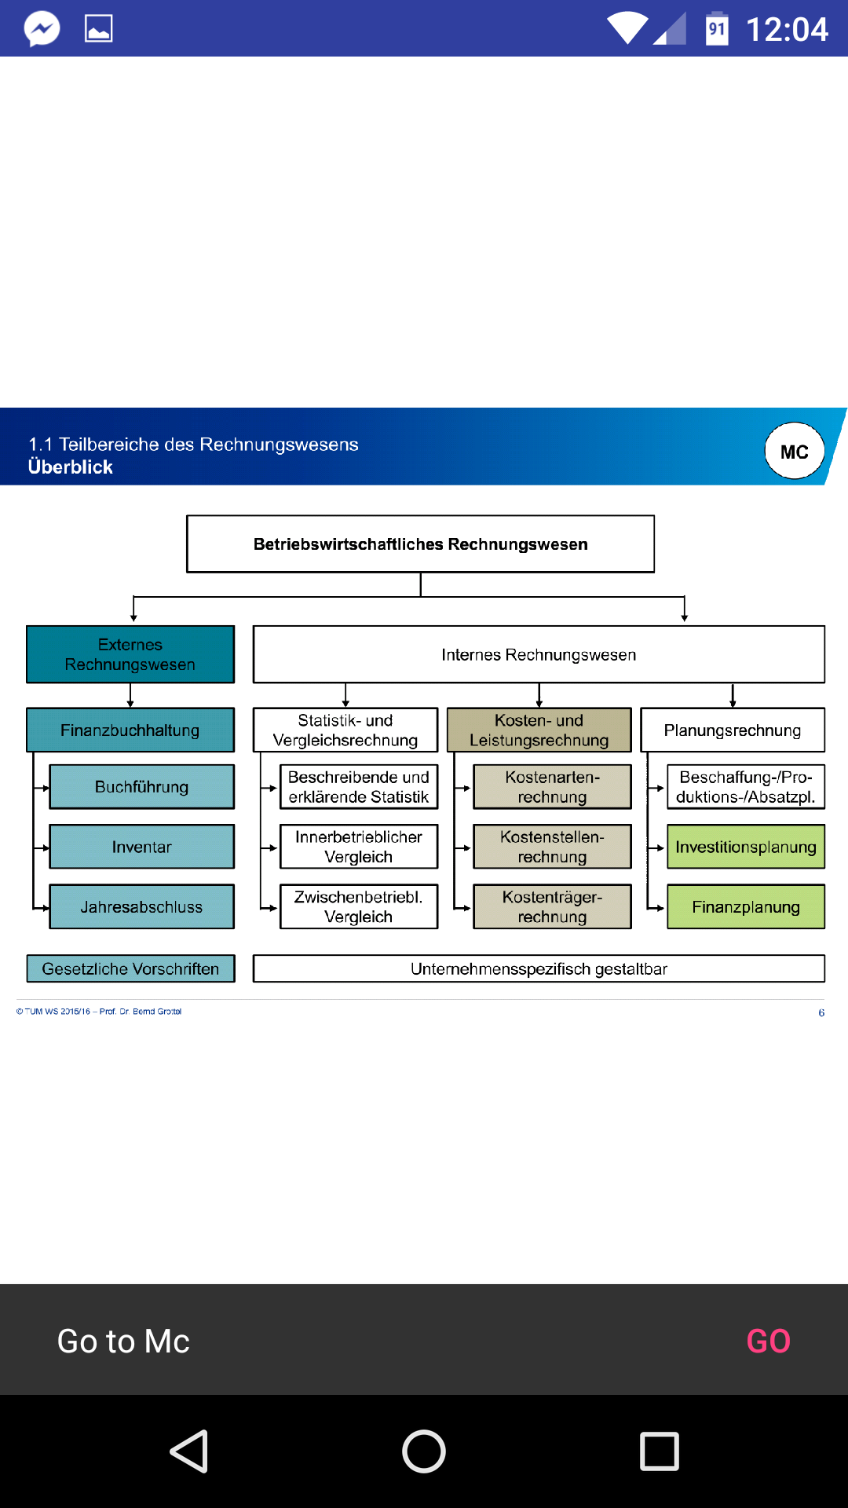

From the side menu you can access all the PDFs. The PDF View can be horizontal and vertical. The PDFs are locally stored in app. If the page has question down will be popped up the small menu with Text “Go to Mc” and “GO” button. After clicking the button you will get the Question view with all fit question to this page.

—WRITE HERE THE LIBRARY FOR PDF—

Coming soon

REQUIRIMENTS

Database have to be done with realm.

In the Future it has to be added the connection to the server to update the DB. (Synch Button)